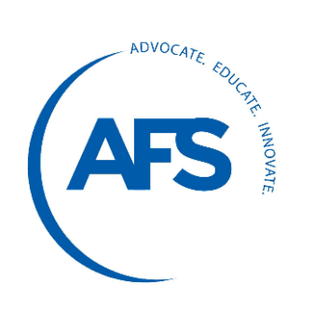

AFS Millionaires Safety Award Application

Award Criteria
The AFS Millionaires Safety Award recognizes AFS Corporate Member facilities, at a single location, which have achieved one-million hours, or any million-hour increment, without a lost-time incident (injury, illness or death). The work-hour count begins the day following the facility’s last lost-time incident. The millionth-hour milestone must have been reached during the period between January 1, 2021, and December 31, 2021.

Note: Reaching the million-hour increment does not mean that all hours were accumulated in 2021. It may take years to achieve, but the final millionth-hour must have been reached during 2021.

Only AFS Corporate Members are eligible to enter. Application deadline is January 31st, 2022. If you have any questions, please email kperna@afsinc.org

Application Details — (Please type/print)

Organization name (Name as it will appear on the plaque):

Award Facility Location: NAICS/SIC:

Process/Product(s) Made: Number of Employees:

Company Contact: Title:

Address:

City: State: Zip:

Phone: E-mail:

Million-hour increment of hours was achieved on , 2020
(Ex. 1 or 2, or 5 million)

Application Verification — (Signed and dated by company officer)

I certify that the above information is correct, and we are an AFS Corporate Member:

Print name: Signature:

Title: Date:

E-mail completed application to:
Kimberly Perna: kperna@afsinc.org
Deadline: January 31st, 2022

