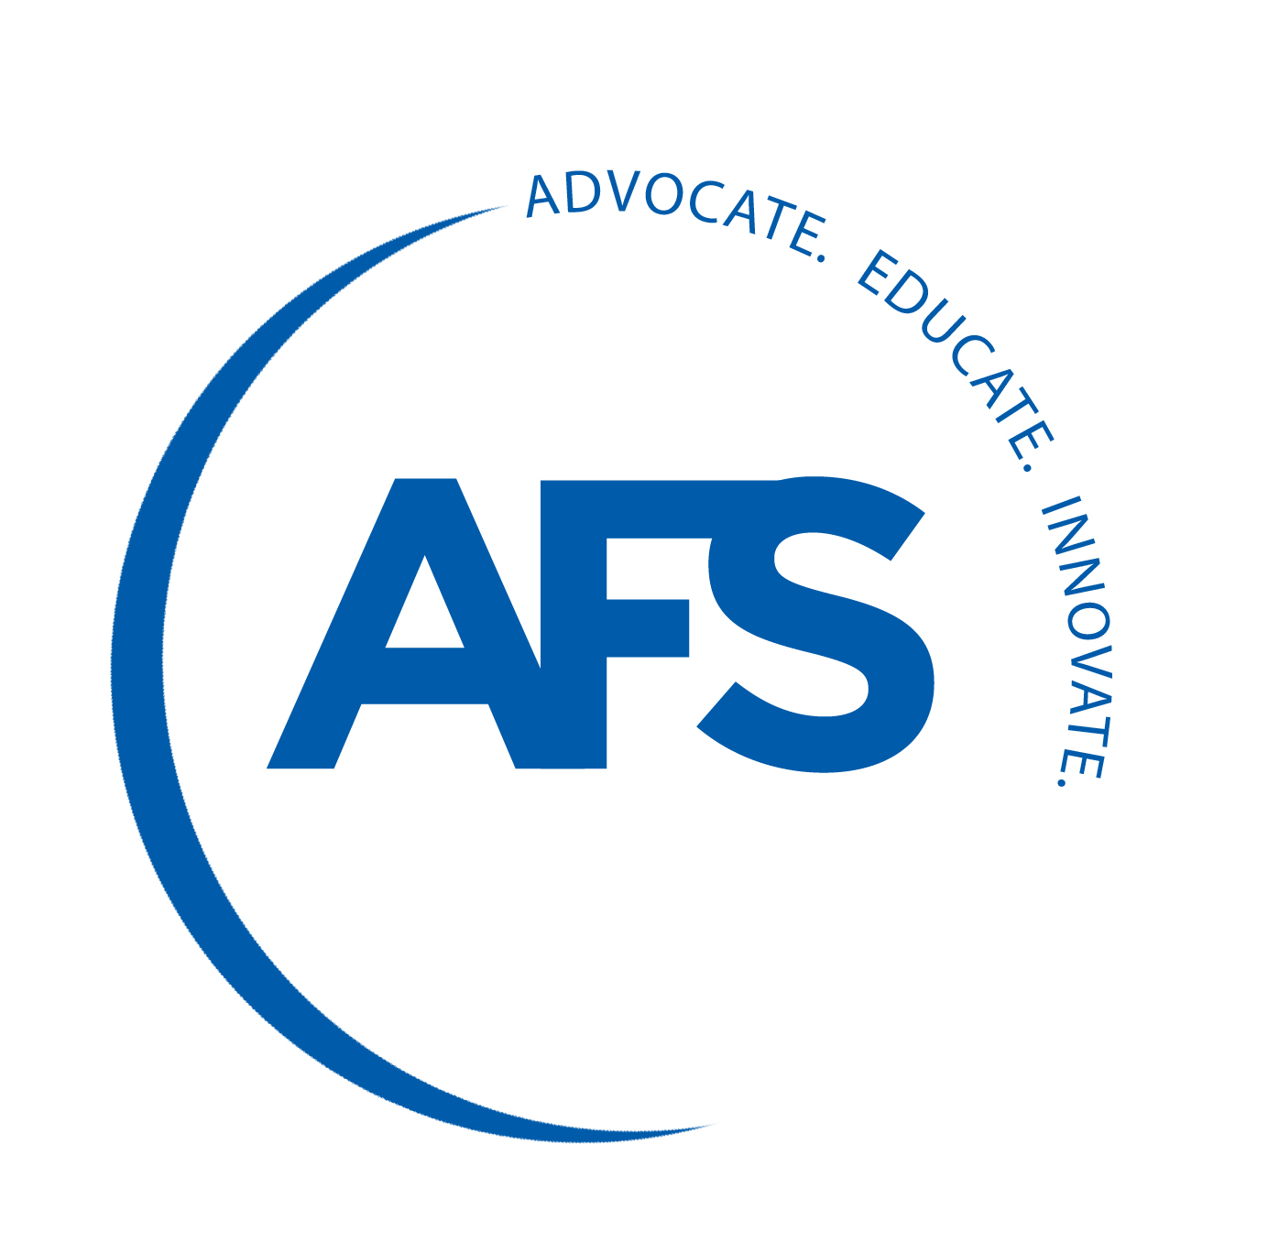award criteria & Nomination Form:
Howard Taylor Award

The AFS Howard Taylor Award was established to recognize a paper, published by AFS and presented at the annual Metalcasting Congress, that has potential long-range technical significance in the field of cast metals technology. The award is intended to inspire technical excellence and forward-thinking innovation and reward the best efforts of the industry’s researchers and technical experts.

NOMINATIONS
- Each technical division of the AFS Division Council should nominate not more than one candidate paper each year for the Howard Taylor Award.
- Nominations are restricted to papers that:
- Have been selected for publication in AFS Transactions.
- Were presented as part of the technical program at the annual Metalcasting Congress organized by the nominating division.
- Papers from the previous three (3) Metalcasting Congresses are eligible.
- The Division Best Paper Award selection and the Ray Witt Management Award are to be considered as separate functions from the Howard Taylor Award and need not necessarily involve the same paper.
- A standard nominating form will be used to submit nominations. This form is to be returned to the Honorary Lectures & Paper Committee Chair in care of the AFS Technical Department.
- Papers must be nominated in essay form in response to the guideline questions. It is the responsibility of each division to explain the virtues of the paper nominated.
- Nominations from the divisions must be received by the deadline date as determined by the AFS staff.
SELECTION
- Evaluation and selection of Howard Taylor Award nominations is a function of the Honorary Lectures & Papers Committee (HLPC). The members on the committee will consist of:
- Chair, past chair, vice-chair, secretary and secretary-elect of the Technical Council, at-large members of the Technical Council, and Chair of the Management Council.
- Vice-chair of the Technical Council shall serve as chair of the HLPC. Other Technical and Management Council members may participate as auditing (non-voting) members.
- All HLPC members will be given an opportunity to review and rank nominated paper. A compilation of those rankings will be provided to HLPC for guidance in making their final selection.
- The HLPC committee will set scheduled meeting dates and times to evaluate the candidate papers for selection a winner.
- It is recommended that the Honorary Lectures & Papers Committee make an award selection each year. However, HLPC may select a nominated paper to receive the award or determine that none of the submitted nominations meet the award criteria.
- Selection will be made from the nominations of the current Metalcasting Congress year; plus the previous two years. All papers from this three-year period are eligible.
- The Honorary Lectures & Papers Committee may seek additional information on any nomination, either from the nominating division or from any other source.

Howard Taylor Award: Nomination Form

PAPER TITLE:

PAPER NUMBER:

Author(s)/Company:

Nominating Division:

EVALUATION:

- What was the technical significance of the work?

- What is the (potential) impact of the work on the field of cast metals technology?

- What is the time span during which the work will impact the metalcasting industry; i.e. immediate, short range (2-5 years), long range? Explain.

- Describe the level of innovation. Does this paper constitute new technology, complete a knowledge base on which new technologies can be built, or improve and advance an existing technology? Please illustrate.

- How does this work respond to an important need? Please illustrate.

