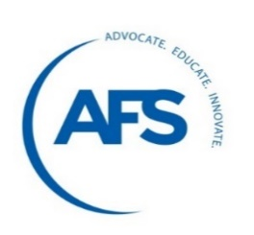 | American Foundry Society  Government Affairs Fly-IN  May 15-16, 2018  Hyatt Regency Capitol Hill – Washington, D.C.

Congressional Hill Meeting Request Form

Last year we scheduled over 100 meetings, please make sure to submit this congressional meeting request form as soon as possible to ensure your meetings are set-up well in advance.
- Please do not contact any legislative office directly regarding your appointments. We are coordinating a large number of meetings and want to keep confusion to a minimum.
- We will need your business and home address (if applicable) to correctly identify which representatives you should meet with.
- Finally, because congressional appointments can and do change up until the last minute, final schedules will not be available until May 15, 2018. Again, everyone who wishes to participate in our legislative meetings should plan to be available all day up to 5:00 pm on that day, if at all possible.
- Hill visits take place with state delegations.

Would you like AFS to schedule your Congressional meetings? ___ YES ___ NO, not available
If you answered YES, please fill out the following:
Name: ____________________________________

Company: __________________________________

Address*: __________________________________

City: _____________________________ State:______ Zip Code:__________________

Office: _____________________ Mobile: _________________________________

Email: _____________________
*Note if you have multiple locations and want to meet with lawmakers in more than 1 state.
I would like to meet with:
- Senators
List Names _____________________________ ________________________________

- House of Representatives
List names ________________________________________________
________________________________________________

________________________________________________
We look forward to seeing you in Washington, D.C. In the meantime, if you have questions regarding the congressional meetings scheduling process, please contact Stephanie Salmon – AFS Washington Office – ssalmon@afsinc.org

